SIMS.net - User Guide for Supply Teachers

Getting Started
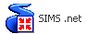
Click on the SIMS.net icon on your desktop or select Start, All Programs, SIMS Applications and click on the SIMS.net option.

Log on to SIMS.net by entering your User name and Password.

Your password is case sensitive!

Opening a Register
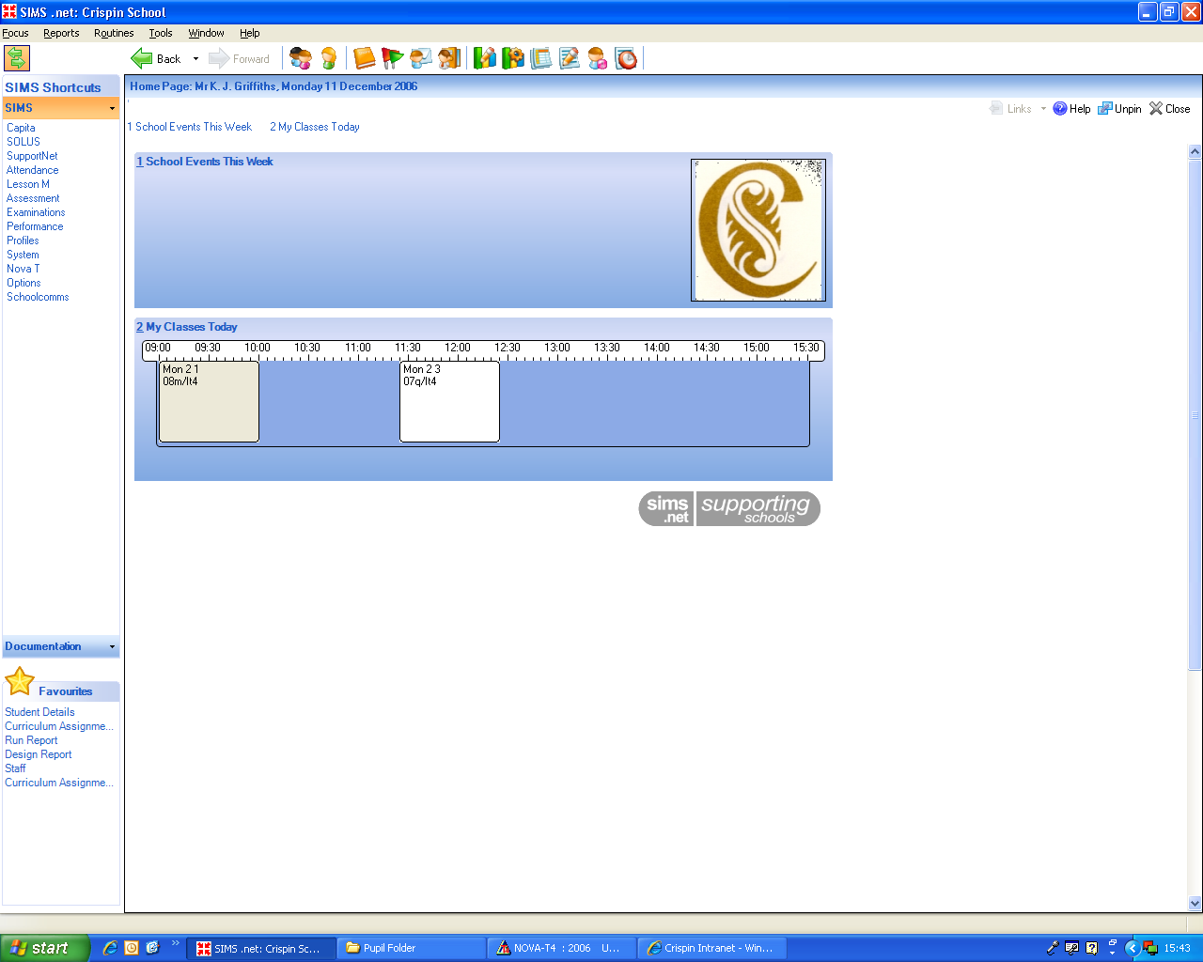
Your timetabled classes are shown as a time-line on the SIMS.net homepage. Double click on the class you wish to register.

Note - This will only appear if you browse your own name or you as an individual are registered on SIMS. Day to day Supply Teachers use a temporary login therefore this is only relevant for Teachers on a long term placement.

Filling in a Register

Your class list will open automatically and show
each pupil’s attendance history during the day so far. Your lesson will appear as a white column. The pupil for whom you are entering a mark will be highlighted in dark orange. The cursor will automatically move to the pupil below as you enter a code.

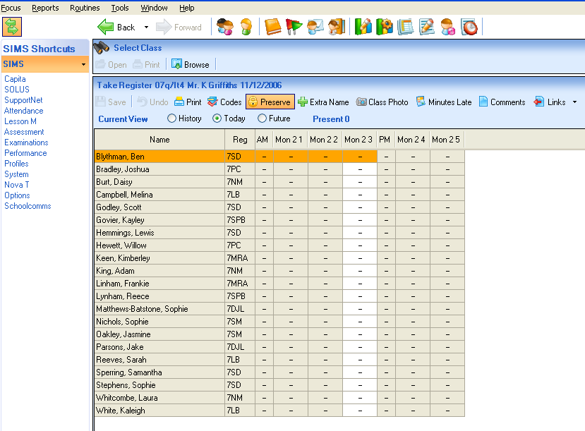

Enter one of the following codes:

/ | Present  Please do not enter or overwrite any other attendance codes
N | Absent
L | Late
Click Save to send the register to the SIMS.net database. Please note that the register will appear as incomplete until you action this.

“PLEASE SEND REGISTERS WITHIN 10 MINUTES OF THE START OF A LESSON”

Late Pupils

If a pupil is late, select their name (highlighted orange), select the Minutes Late button from the panel above the register, enter the number of minutes late and select OK.

Mistakes

Any mistakes prior to sending a register can be corrected straight away.
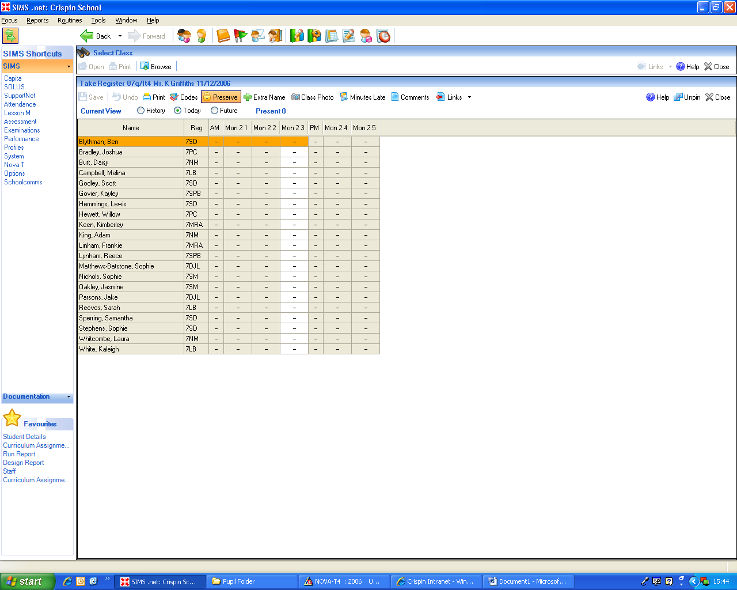
To make alterations after a register has been sent, re-open the register and select the Preserve button situated above the list of pupils. This will change to Overwrite and allow you to change marks previously recorded. Enter the correct code. Save the register again.

Floaters

Some pupils may make a ‘guest appearance’ in another class. This is most likely to be with a Head of Year/Department/SLT. These pupils can be registered along with your timetabled class, regardless of their year group.

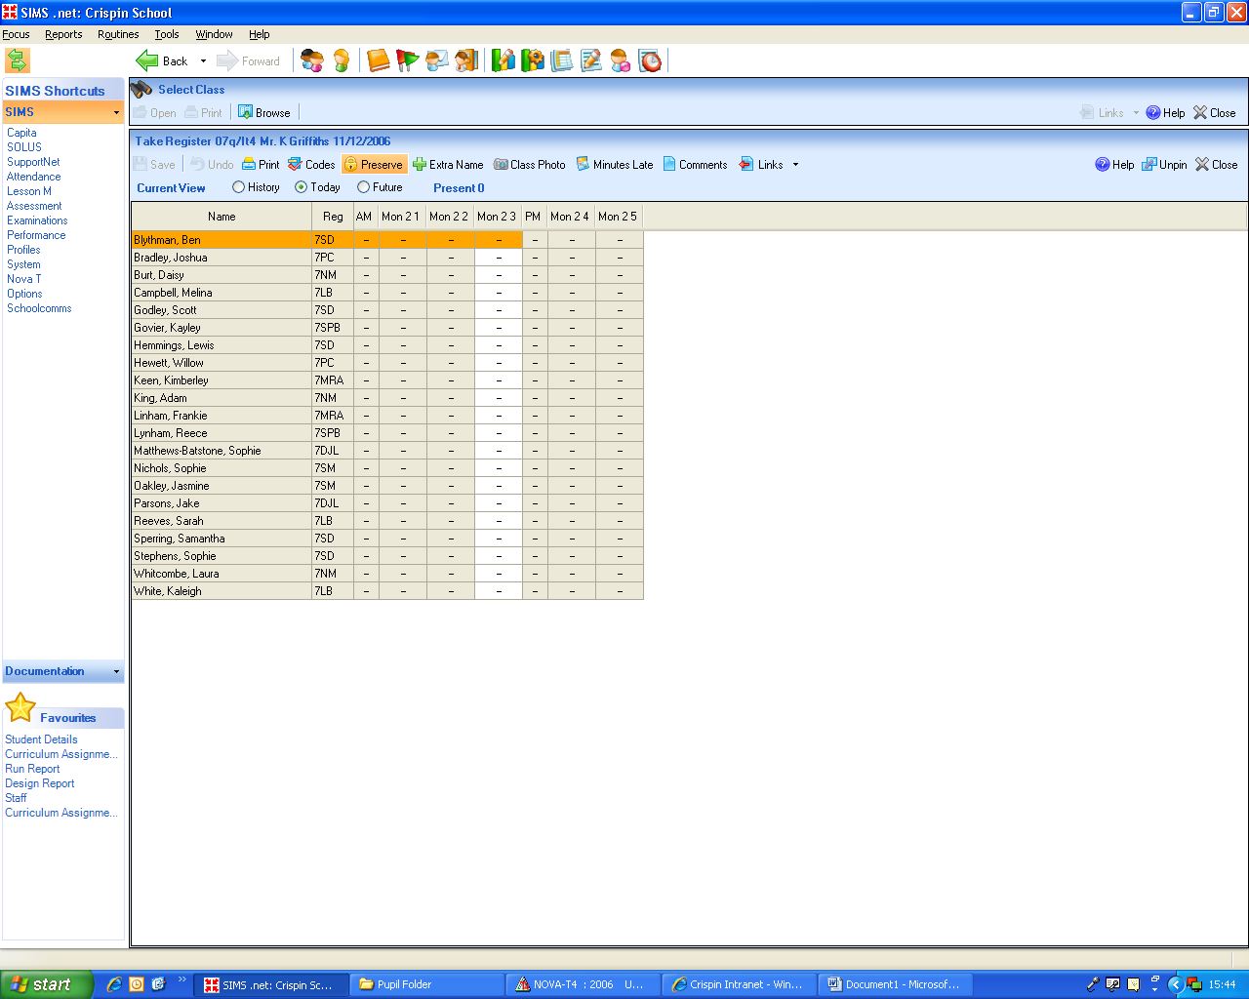
Select Extra Name from the top of your register. Search for the name of the pupil, select them and click OK. The pupil will automatically be marked present (/).

Reviewing Past/Future Attendance

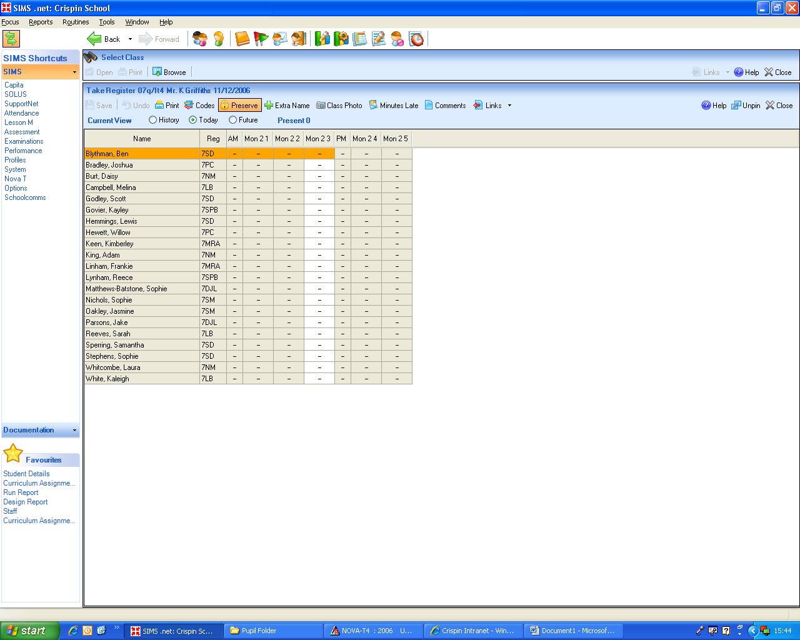
The radio buttons at the top of your register will allow you to review past and future attendance.

Supply/Cover

If you wish to register a class that you do not teach select Focus, Lesson Monitor, Take Register from the menu bar at the very top of your screen.

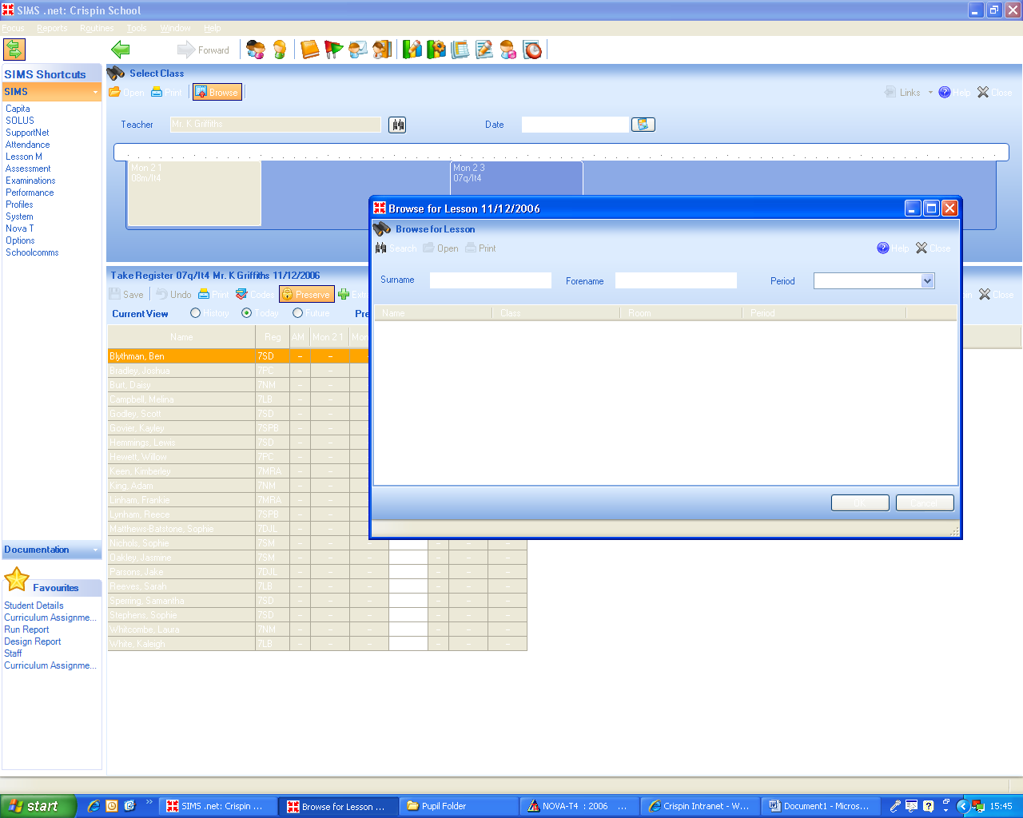
Select the binocular icon to open the Browse for Lesson window. Type in the name of the teacher and/or the period you wish to register. Click OK. Click on the correct class from the list that appears. The lesson will register open and can be completed and saved in the same way as other registers.

Supply staff will be issued a temporary log-in.


Other Features

- Selecting the Class Photo button displays the photographs of class members!

- Selecting the Add Comment button allows you to make notes against the name of a specific pupil for that particular lesson i.e. no it, no ingredients.

Data Protection

Parents have a right to view data, in any form, held by the school on their son/daughter. This includes comments entered during registration. Please keep the comments formal.

If you leave your computer un-attended you must either log-off or ‘lock’ your computer. To lock a computer press Ctrl-Alt-Delete and select ‘Lock this workstation’. You will then be prompted for a password. If you leave a room during break and/or lunchtime please lock your computer and the door.

Do not take the register whilst displaying it through a data projector (select Hide on the handset)

